**Assignment**

**Step-by-Step HTML and CSS Practice Instructions**

**Step 1: Set Up the HTML Structure**

1. Open your preferred text editor or integrated development environment (IDE).
2. Create a new HTML file and name it **index.html**.
3. Inside the **index.html** file, create the basic HTML structure with **<html>**, **<head>**, and **<body>** tags.

**Step 2: Add CSS Styling**

1. Create a new CSS file named **styles.css**.
2. Link the **styles.css** file to your HTML file using the **<link>** tag inside the **<head>** section.
3. Open the **styles.css** file.
4. Target html elements and style it according to your design preferences using basic CSS properties like **padding**, **margin**, **font-size.**

**Step 3: Populate the Table with Data**

1. Inside the **<table>**, add **<tr>** tags to represent each row of data.
2. Inside each **<tr>**, add **<td>** tags to represent data cells.
3. Populate the data cells with sample data relevant to your practice scenario.
4. on your learning objectives and design preferences.
5. Continue practicing and exploring additional HTML and CSS concepts to improve your skills.

Layout:

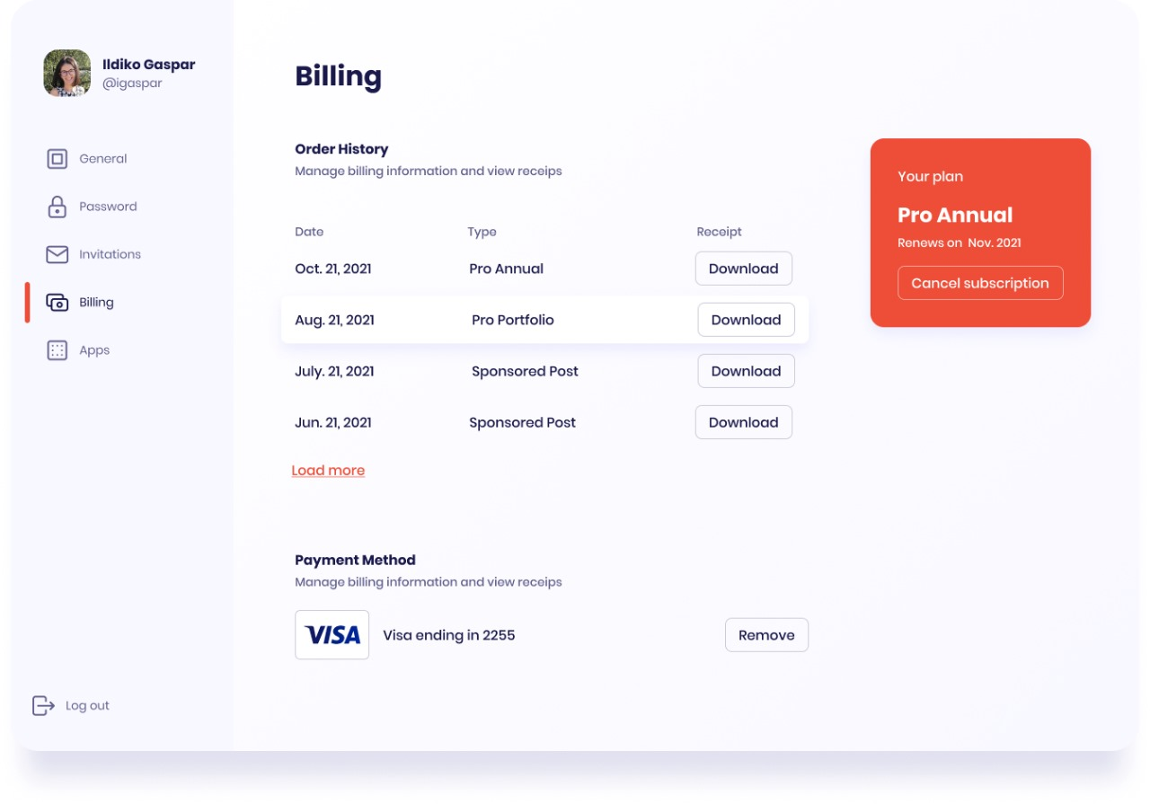

Top of Form